CLASS WORK REPORT

This is the screenshot of the 2 customer accounts that was used during the class work. One customer account was debited and the other was credited.

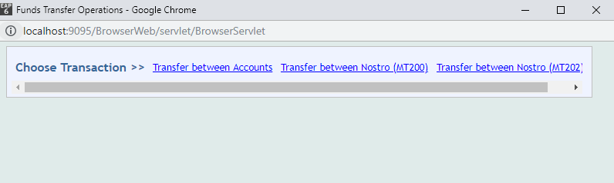

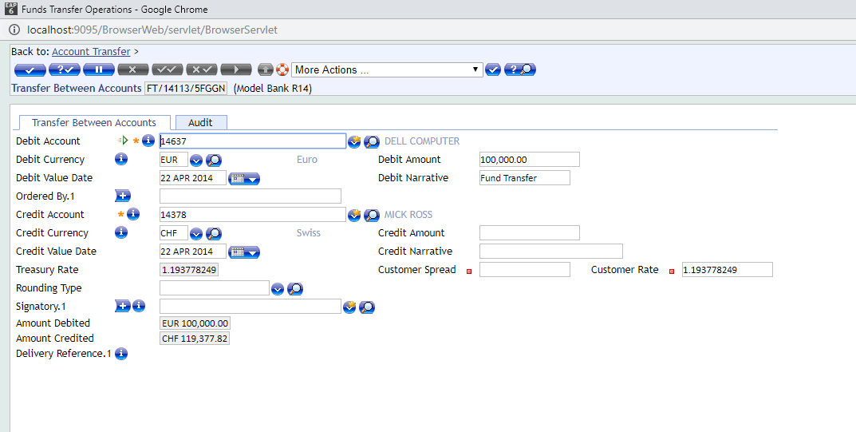

After committing the deal and validating the deal, the below screenshot shows the transaction output

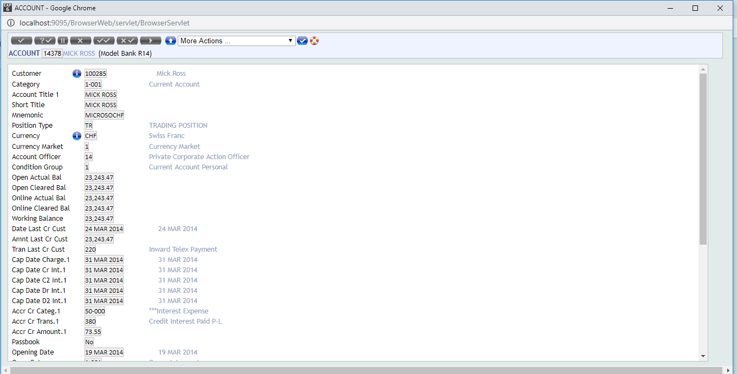

The above account with account number 14637 was debited wit 100,000 euro. The below account was credited with 100,000 CHF

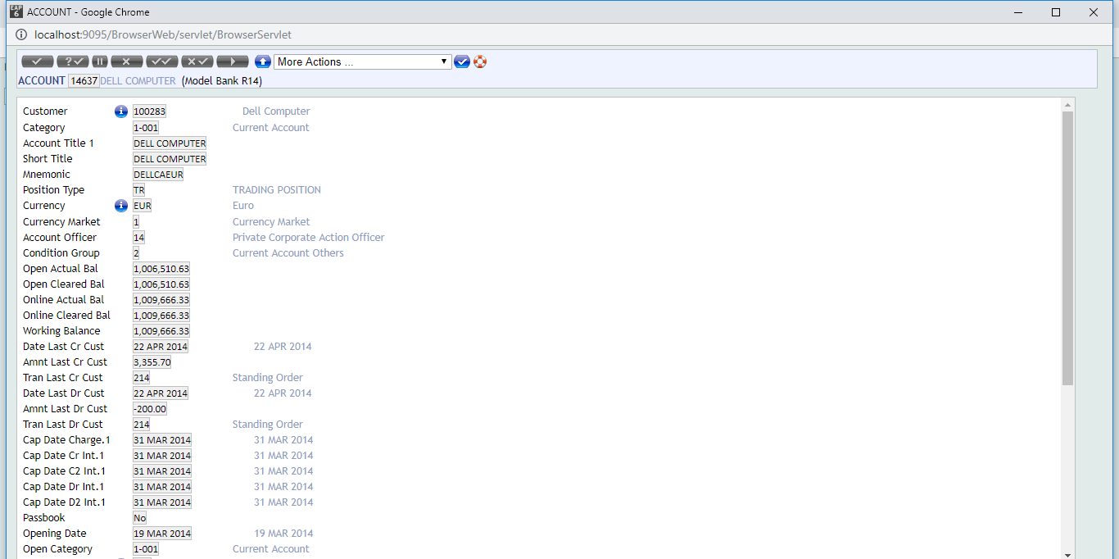

Their currency is differ and the system automatically converts the 100,000 euro to 119,377.82

After authorizing the transaction, 100,000 euro was debited from the first customer and 119,377.82 was added to customer 2 balance.

Open actual balance, open cleared balance for the 2 customers does not change but Online actual balance, online cleared balance and working balance was updated due to the credit and debit.

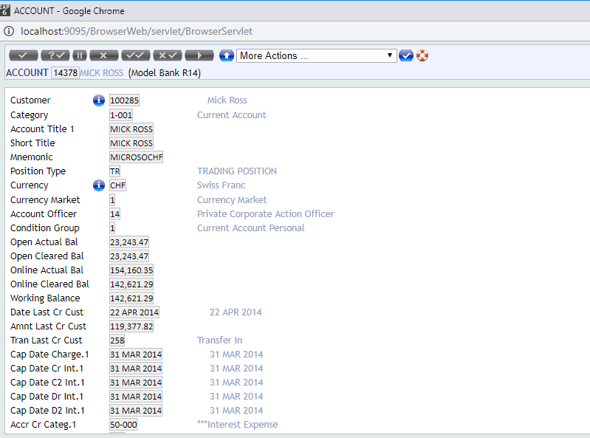



Next Day Transaction

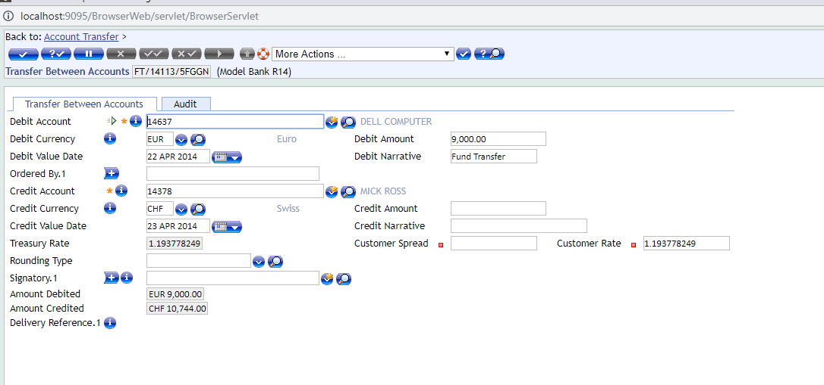

The below screenshot is after COB (Close of Business). Open actual balance, open cleared balance, online actual balance, online cleared balance and working balance were updated to reflect the credit and debit transactions

